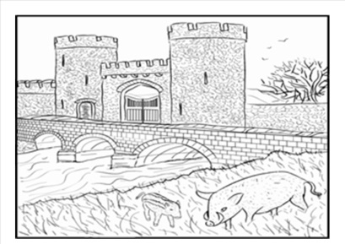  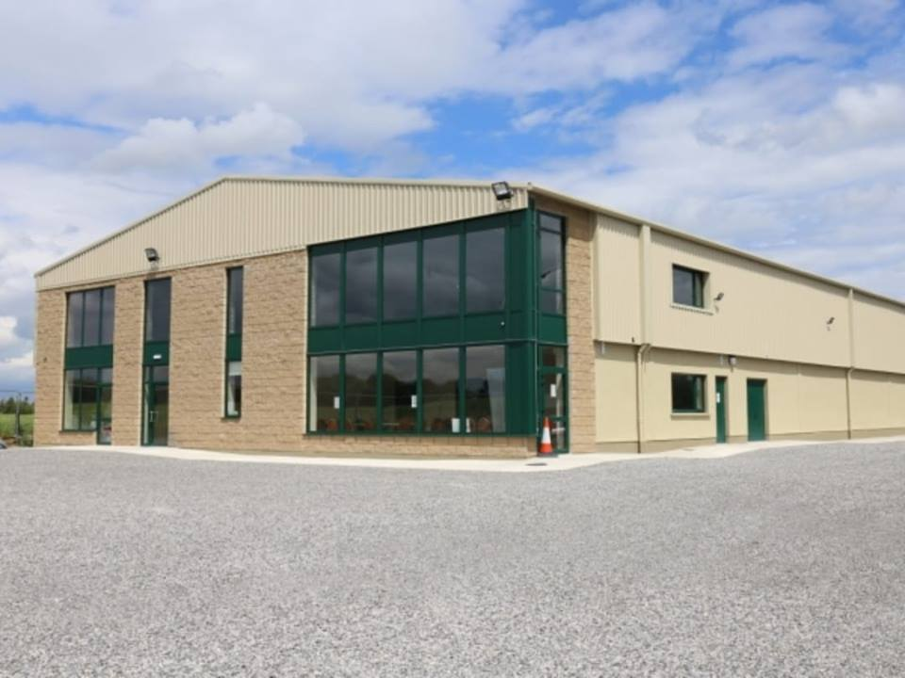 | Safety Statement
 | In accordance with the Safety, Health and Welfare at Work Act, 2005
Mucklagh Community Development Ltd.,
Mucklagh,
Co. Offaly.

Prepared by:

Midland Safety Services
No. 1 Broughal Road,
Kilcormac,
Co. Offaly.

Date:
September 2018

Table of Contents

1.0 Introduction 7
1.1 Health and Safety Policy 8
1.2 Health and Safety Aims 9
1.3 Health and Safety Objectives 9

2.0 Roles and Responsibilities 10
2.1 Duties of Employer 10
2.2 Duties of Employees 11
2.3 Contractors 12
2.4 Visitors and Inspectors 13

3.0 Competence and Training Requirements 14

4.0 Consultation and Participation 15

5.0 Accident Reporting and Investigation Key Actions 16

6.0 Emergency Procedures 17
6.1 Key Actions 17
6.2 Evacuation 17
6.3 First Aid 17

7.0 Personal Protective Equipment (PPE) Key Actions 18
7.1 Conditions for Personal Protective Equipment (PPE) Use 18
7.2 Expectations from employees in relation to use 18
of Personal Protective Equipment (PPE)

8.0 Inexperienced Persons 19

9.0 Policies and Procedures 20
9.1 No Smoking Policy 20
9.2 Environmental Policy 20
9.3 Dignity and Respect to all Employees Policy 21
9.4 Anti-bullying Policy 22
9.5 Disciplinary Procedures 23
9.6 Safe Working Procedures Policy 24

Table of Contents
10.0 Occupiers’ Liability Act 1995 25
10.1 Introduction 25
10.2 Classes of Entrant 25
10.3 Visitors 26
10.4 Recreational Users 26
10.5 Trespassers 26
10.6 Duty Owed to Visitors by Committees Set Up in Each 26
Area (in which Mucklagh Community Development Ltd. Employees/volunteers work)
10.7 Duty of Care Definition 27
10.8 Visitors Duties 27
10.9 Employees Duties 27

11.0 Ground Floor Plans

12.0 Risk Assessment Matrix 28
12.1 Hazard Identification and Risk Assessment Criteria 28
12.2 Risk Assessment Classification 28

13.0 General Hazards Associated with Works Carried Out by Employees
of Mucklagh Community Development Ltd.
RA/01 Electricity
RA/02 Fire
RA/03 Slips, Trips and Falls
RA/04 Manual Handling
RA/05 Chemicals
RA/06 Working at Height
RA/07 Display Screen Equipment
RA/08 Office Equipment
RA/09 Broken Glass/ Crockery
RA/10 Cleaning
RA/11 Kitchen Equipment
RA/12 General Equipment
RA/13 Loading/Unloading
RA/14 Manually Operated Hand Tools
RA/15 Noise
RA/16 Vermin and Pest Control
RA/17 Biological Agents
RA/18 Contractors
RA/19 Hiring the hall for parties
RA/20 Hiring the hall for various activities
RA/21 Vehicle movement
RA/22 Hiring of the kitchen
RA/23 Hiring of training rooms
RA/24 Hiring of offices
RA/25 Welfare Facilities
RA/26 Use of Lift
RA/27 Hiring of Rooms for NS teaching purposes

13.0 Site Specific Operations and Controls
Area 1: Meeting Rooms
Area 2: Office
Area 3: Kitchen
Area 4: Main Hall
Area 5: Welfare Facilities
Area 6: Storage Areas
Area 7: Reception
Area 8: Parking Area
Area 9: Second Floor

Appendix 1: General Principles of Prevention
Appendix 2: Accident Investigation Form
Appendix 3: SDS Sheets

Signature Page

- Introduction
  - Mucklagh Community Development
Mucklagh Community Development Ltd by guarantee formed in 2009 with the aim to build a Community Centre and to provide and develop services for all members of the community. Today they a beautiful community centre that comprise of an entrance, toilets, a large sports hall, toilets, shows, storage, a large kitchen, meeting room and office. Upstairs comprise of two large committee rooms, office, storage, kitchenette, toilets and balcony.
To date Mucklagh Community Development Ltd. is a place where people and groups hire to develop services, set up groups, such as Active age, Foroige Youth group and at the moment Community Text Alert being established. Established groups such as GAA, Soccer, Basket Ball, Community Games, Birthday Parties, refreshments after funerals/Masses just to name a few all use Mucklagh Community Development Ltd.. The Centre is open up to 13 hours a day and is run by volunteers along with help from personnel through various social schemes. Our Motto is Building for the future and our mission statement is as follows: Mucklagh Community Development Co Ltd is committed to Social, Educational, Sports and Cultural Integration of the people of Mucklagh and surrounding areas.

1.2 Community Employment ( CE) Scheme
The Community Employment (CE) programme is designed to help people who are long-term unemployed and other disadvantaged people to get back to work by offering part-time and temporary placements in jobs based within local communities. Participants can take up other part-time work during their placement. After the placement, participants are encouraged to seek permanent part-time and full-time jobs elsewhere based on the experience and new skills they have gained while in a Community Employment scheme. The scheme aids participants regain their confidence in themselves and their ability to work. A secondary function of the Community Employment Scheme is to provide much needed resources for local villages and their facilities.

The Community Employment programme is administered by the Department of Social Protection (DSP).

Community Employment sponsors - the voluntary organisations or public bodies that manage CE schemes - plan and manage CE placements. They sponsor local or community projects that meet an identified community need.

1.3 Safety Statement
This Safety Statement has been compiled in accordance with the Safety, Health and Welfare at Work Act 2005, Sections 19 and 20. It is management’s statement in writing on the following:

- How they intend to manage and conduct work activities to ensure the safety, health & welfare of all persons associated with the safe running of the various activities

- How they intend to manage and conduct work activities to ensure the safety, health & welfare of all persons invited to the premises to take part in various activities.

  - Activities that take place in meeting rooms
    - Active Age Groups
    - Yoga Classes
    - Pilates Classes
    - Tuition Classes
    - General Meetings
  - Activities that take place in the hall
    - Birthday Parties
    - First Communion Parties
    - Games
    - Gatherings following a funeral
  - Activities taking place on second floor meeting rooms
    - National School Teaching

- How the intend to manage and conduct work activities to ensure the safety, health & welfare of all persons employed by various groups to carry out working activities such as :
  - General Caretaking
  - General Maintenance Works
  - Cleaning

1.0 Introduction - CONTINUED

1.4 Health and Safety Policy

Management of Mucklagh Community Development Ltd. are committed to protection the health and safety, so far as is reasonably practicable, of its employees, volunteers, and the wider public when engaged in activities managed or promoted by this group.

All employees are required to take reasonable care of their own health and safety while complying all rules and safe working procedures put in place for their safety. The health and safety policy below outlines the commitment undertaken by the employees of Management of Mucklagh Community Development Ltd. to this endeavour.

We, at Management of Mucklagh Community Development Ltd. are committed to working in accordance with the relevant statutory provisions and other associated legislation where relevant and the requirements of this Safety Statement. We shall endeavour to manage and co-ordinate safety and health and ensure, so as far as is reasonably practicable, that:

- Accidents and causes of ill-health are prevented and adequate and efficient control measures are put in place to ensure risk is avoided/minimised.
- The safety statement is maintained and updated, risk assessments are carried out and reviewed as required and brought to the attention of employees.
- Preventive measures (rather than reactive) are implemented and maintained.
- Improper conduct likely to put anyone’s safety and health at risk is prevented.
- A safe means of access and egress is provided.
- Safe plant and equipment are provided.
- Safe systems of operations are in place.
- Risks to health from any activity, article or substance are prevented.
- The provision of appropriate training is promoted and relevant instruction is provided by a competent person to ensure all employees are aware of safe working procedures and are facilitated to carry out their work as safely as possible.
- Where hazards cannot be eliminated, adequate arrangements, including the provision of suitable protective clothing and equipment, will be put in place to reduce the risk of injury.
- Emergency plans are prepared and revised as necessary.
- Respect and protection of each member’s dignity is promoted.
- Learning and teaching abilities are shared with skills and knowledge comfortably used and passed on to others in a safe manner.
- Helping out with activities taking place in the community is promoted.
- Informal chats if that is all a employees is looking for is facilitated.
- Safety, health and wellbeing of all employees is a priority.

Signed: ______ __________________ ______
Chairperson of the Committee Date: _______________

1.0 Introduction - CONTINUED

1.5 Health and Safety Aims

It is the aim of Management of Mucklagh Community Development Ltd. to ensure that employees are provided with a safe and healthy recreational and work environment. The Management of Mucklagh Community Development Ltd. are committed to minimising risks to employees and visitors by identifying all the occupational hazards and eliminating their associated risks. However, where it is not reasonably practicable to eliminate the risk, adequate control of the hazard must be achieved through the implementation of safe systems of work, provision of training and the provision of Personal Protective Equipment.

1.6 Health and Safety Objectives

In order to achieve the objectives, Management of Management of Mucklagh Community Development Ltd. will:

- Ensure legal requirements are met.
- Provide information to employees on legislation, codes of practice and any other information which would assist safe working practices.
- Develop and operate safe working practices and procedures.
- Develop an awareness in each member of his personal responsibility for the safety of himself and fellow employees, through information, training supervision and consultation.
- Engage the assistance of competent people when needed e.g. training, electrical work, emergency plans, carpentry work.
- Communicate the contents of the safety statement to all employees and ensure the safety statement is accessible to them at all times.

To ensure these objectives are met, Management of Mucklagh Community Development Ltd. is committed to playing an active role in the implementation of the safety statement, and will undertake to review and update the statement at regular intervals. This document is a working document.

2.0 Roles and Responsibilities

2.1 Duties of Employer

- Manage and conduct activities so as to ensure the safety and health of employees and others who may be affected the activities.
- Manage and conduct work activities in such a way as to ensure, so far as is reasonably practicable, the safety, health and welfare of all employees.
- Manage and conduct work activities in such a way as to prevent, so far as is reasonably practicable, any improper conduct or behaviour likely to put the safety, health or welfare of employees at risk.
- Provide safe means of access and egress.
- Provide safe equipment and machinery.
- Provide safe procedures for activities and work parties.
- Ensure compliance with the safety rules by all persons works on the premises or surrounding areas.
- Prevent risk to health from any machinery, equipment and chemical substances.
- Provide appropriate information and instruction, and training and supervision where relevant.
- Provide suitable protective clothing and equipment where hazards cannot be eliminated.
- Provide welfare facilities.
- Identify training needs and provide necessary training.
- Provide emergency plans.
- Apply the General Principles of Prevention - Refer to Appendix 1

2.0 Roles and Responsibilities - CONTINUED

2.2 Duties of Employees

- Comply with the relevant statutory provisions, as appropriate, and take reasonable care to protect his safety, health and welfare and the safety health and welfare of any other person who may be affected by the employee’s acts or omissions at work.
- Comply with safety policies and procedures to ensure own personal safety and health, as well as that of others.
- Ensure that he/she is not under the influence of an intoxicant to the extent that he is in such a state as to endanger his or her own safety, health or welfare, at work or that of any other person.
- Comply with the relevant health and safety requirements laid down in this safety statement e.g. safe working procedures.
- Report all hazards, injuries, incidents, dangerous occurrences and near misses as soon as possible and on the same day to the person in charge.
- Report any defects in equipment, unsafe activities or deficiencies in safety procedures.
- Use protective clothing and equipment.
- Comply with the safety rules.
- Do not engage in improper conduct or behaviour that is likely to endanger your own or other’s safety, health and welfare
- Do not interfere with, misuse or damage anything that may affect anyone’s safety, health and welfare.
- Attend such training and, as appropriate, undergo such assessment as may reasonably be required by the person in charge to ensure competency.
- Having regard to his or her training and the instruction given by his or her employer, make the correct use of any article or substance provided by the employer at work, or for the protection of his or her safety, health and welfare at work, including protective clothing or equipment.
- Report to his or her employer or to any other appropriate person, as soon as is practicable.
- A potential employee, on joining Mucklagh Community Development Ltd. should not misrepresent himself/herself.
- Any person is prohibited from intentionally or recklessly interfering with, misusing or damaging anything provided under health and safety legislation, or provided to protect the safety, health and welfare of persons at work, or at place of risk to safety, health or welfare in connection with work activities without reasonable cause.
- Do not act negligently causing injury/ill-health to any other member, visitor or anyone else affected by the activities.

2.0 Roles and Responsibilities - CONTINUED

2.3 Contractors

A contractor is a person or organisation that signs a contract to do certain work for payment within a specified time.

A contract requires three elements:

- offer,
- acceptance, and
- Consideration.

All contractors engaged will comply with the following duties:

- All Contractors will provide:

- Details of Insurance.
- Provide their own safety statement.
- Complete the SSWP for the works.
- Co-operate with safe working procedures and current codes of practice.
- Provide information on hazards the contractor will present to employees.
- Comply with construction regulations.
- Maintain good housekeeping.
- Ensure all persons carrying out the work are competent and have relevant training.
- Comply policy for this organisation.
- Adequate resources to carry out the work safely.

All contractors must be competent and ensure that work activities do not affect the well-being of our employees or visitors.

2.0 Roles and Responsibilities - CONTINUED

2.4 Visitors and Inspectors

2.4.1 A visitor is a person who has been invited onto the premises for the purpose of:
  - Use of the hall, welfare facilities, kitchen facilities
  - Employees to carry out their work
  - Contractors to carry out their work

2.4.2 An inspector is a person who may or may not have been invited onto the premises but are entitled to enter the premises to carry out an inspection.

2.4.3 All visitors and inspectors to the premises are required not to act in a negligent manner so as to cause an injury. They must take care of their own safety in as far as is reasonable. They should:

- Conduct themselves in a safe manner at all times.
- Observe emergency procedures.
- Comply with safe rules.

2.4. 4 Management of Mucklagh Community Development Ltd. have a duty to ensure persons they are inviting to their premises are not put in danger. They will:

- Practice good housekeeping.
- Keeping walkways clear.
- Cleaning up spills immediately.
- Restrict access to hazardous areas.
- Prevent visitors from using equipment or machinery.
- Ensure appropriate safety signs and notices are displayed.
- Ensure safe walkways and access routes are maintained.
- Put procedures in place to ensure visitors are evacuated in a safe and timely manner in the event of an emergency.

3.0 Competence and Training Requirements

Competence is determined by knowledge, training and experience for the type of activity being carried out.

Competency will ensure all employees will be capable of completing an activity safely.

Activities and training requirements carried out at Mucklagh Community Development Ltd. include:

- Training which may be carried out:

- First Aid and CPR.
- Fire Fighting Equipment.
- Manual Handling.
- Use of Personal Protective Equipment (PPE).
- Working at Heights Equipment e.g. ladders and scaffolding
- Identification of Hazards in the workplace.
- Risk Assessments and Control Measures.
- Legal Responsibilities.
- Safe Working Procedures (e.g. moving of tables & chairs, cleaning etc)
- Safe work procedures when working close to members of the public e.g. residential, public roads etc.

4.0 Consultation and Participation

The Management of Mucklagh Community Development Ltd. recognise the importance of employees participation in safety, health and wellbeing.

4.1. Organisation Chart
Mucklagh Community Development Co Ltd By Guarantee
Centre Management Committee
Lotto Committee
Building/Maintenance
Finance
Fund raising/Event Committee

MCDCL Committee 2018-2019
Surname | First name | Contact no |  | Surname | First Name | Contact no
Barron | Philip |  | 14 | Larkin | Aidan
Brady | Melissa |  | 15 | Leahy | John
Bryant | Caroline |  | 16 | Mannion | Nicola
Carley | Martin |  | 17 | Murray | Fiona
Condron | Martin |  | 18 | McLoughlan | Shane
Cotter | John |  | 19 | McMorris | Sammy
Dolan | Brian |  | 20 | Neville | Frances
Flynn | Gretta |  | 21 | Neville | Mary
Guinan | Magaret |  | 22 | O Grady | Willie
Guinan | Frank |  | 23 | O Kelly | Alison
Grennan | Gerry |  | 24 | O Kelly | Ita
Halstead | Grant |  | 25 | Philips | David
Lawless | Maureen |  |  | Teahan | Ann
MCDCL Directors 2018-2019
Bryant | Caroline |  | 7 | Lawless | Maureen
Barron | Philip |  | 8 | Murray | Fiona
Condron | Martin |  | 9 | McMorris | Sammy
Cotter | John |  | 10 | Neville | Frances
Dolan | Brian |  | 11 | O Grady | Willie
Guinan | Margaret |  | 12 | Philips | David
MCDCL Sub Committees 2018- 2019 To be decided at first meeting after AGM
Finance Fundraising |  |  | Centre |  | 86
 |  |  | O Kelly | Aliosn | Cotter | John
 |  |  | Barron | Phulip | McDonagh | Enda
Barron | Phlip |  | Barron | P.J | McLoughlan | Shane
Bryant | Caroline |  | Bryant | Caroline | Philips | David
Flynn | Gretta |  | Flynn | Gretta | Shorthall | Qilver
Foster | Bernie |  | Grennan | Gerry
Grennan | Gerry |  | Guinan | Mags
Leahy | John |  | Mannion | Nicola
Mannion | Nicola |  | McMorris | Sammy
McMorris | Sammy |  | Neville | Frances
Neville | Frances |  | Teahan | Anne
O Kelly | Alison
O Grady | Willie
Lotto
Carthy | Cep |  |  |  | Coyne | Derek
Barron | Philip |  | Burke | Colm | Guinan | Margaret
Halsted | Grant |  | O Grady | Willie
All employees are encouraged to consult with management to identify training needs for themselves, to give their opinions on safe working procedures, to consult on all matters of safety, health and wellbeing which concern them.

Consultation takes place on a monthly basis with the committee meeting.

All risk assessments will be discussed with employees to ensure their input is heard and acted upon should the need arise. Where there is new equipment introduced, or a change, update or modification in safe working procedures all employees will be advised and their opinion sought. All employees opinions are valued and considered.

5.0 Accident Reporting and Investigation Key Actions

If an accident or incident occurs during an event or in the course of our activities which has affected a member or visitor the following procedures are in place:

- Ensure details of the accident are recorded
- Promptly have the accident investigated by a competent person so as to determine the root cause and to put in control measures to ensure this type of accident does not occur again.
- All accidents and incidents will be recorded in the Accident Report Book.
- Where an accident involving a contractor occurs, the employer of the injured party is responsible for the reporting of accidents on Form IR1 to the Health and Safety Authority.

6.0 Emergency Procedures

It is the responsibility of management to ensure that they have adequate first aid and firefighting equipment in each area. Employees should all be made aware of the emergency procedures in place in each area.

6.1 Key Actions

- Identifying the types of emergency situations that could occur and ensuring that suitable plans and procedures are put in place for dealing with them e.g. fire, explosion, ill-health.
- Ensuring that employees are informed of the specific plans and procedures in place to deal with emergencies.
- Designating where employees are needed to implement emergency plans and procedures.
- Providing the equipment and training needed to deal with an emergency.

Emergency in the hall when used by a hirer:

The Hirer must:
• call the Fire Brigade before attempting to fight any fire;
• only attempt to fight a fire with the equipment provided and if it is safe to do so;
• only use the fire fighting equipment if you have read and understood the instructions or are familiar with the equipment and its specific application and advise Council if emergency equipment is used;
• not continue to fight the fire beyond the first 30 seconds. If the fire is not extinguished within that time, the Hirer must commence the evacuation procedure. A handy guide is that if the fire cannot be extinguished by use of a single extinguisher, then evacuation is necessary

6.2 Evacuation

Each member should know:

- Location of firefighting equipment and means to raise the alarm.
- Location of assembly point where relevant.
- GO IMMEDIATELY TO THE NEAREST EXIT.
- DO NOT WAIT TO FIND OUT WHAT IS HAPPENING.
- DO NOT STOP TO COLLECT PERSONAL ITEMS.
- GO AT ONCE TO THEIR ASSEMBLY POINT AND WAIT FOR FURTHER INSTRUCTION.
- DO NOT RE-ENTER THE LOCATION UNTIL AUTHORISED TO DO SO BY THE EMERGENCY SERVICES.

6.3 First Aid

After assessment of the location and the work activities Management will ensure:

- At least one adequately stocked and accessible first-aid kit will be provided.
- A person is appointed to take charge of first-aid equipment, keeping it stocked and in date.
- Emergency Procedures with emergency services number, nearest doctor and hospital will be displayed in a prominent position on the premises.

For more information refer to Fire Safety Register

7.0 Personal Protective Equipment (PPE) Key Actions

Where it has been identified that the risks cannot be completely eliminated and hence that appropriate Personal Protective Equipment (PPE) is necessary, it will be provided and it must be worn by all employees participating in work parties.

Typical PPE would include:

- Eye Protection.
- Hearing Protection.
- Gloves.
- Safety Footwear.
- High Visibility Clothing.
- Dust Masks.

7.1 Conditions for Personal Protective Equipment (PPE) Use

- PPE must be provided and be suitable for the task.
- PPE must be maintained, used and replaced in accordance with the manufacturer’s instructions.
- PPE is to be used only as a last resort when a residual risk remains after all other measures have been taken to eliminate/reduce the risk.
- Where it is not possible to reduce or eliminate the risk, then PPE appropriate to the task and work environment, as identified in our risk assessments will be used.

Management will keep records of supply and use of PPE.

7.2 Expectations from employees in relation to use of Personal Protective Equipment (PPE)

All employees will be expected to:

- Use PPE correctly.
- Report any defects or damage to PPE immediately.
- Participate in any training or instruction provided on PPE.
- Inform us of any medical conditions they have that might be affected by the use of the PPE provided to them.

8.0 Inexperienced Persons/Young Persons/Children

Management is aware that some inexperienced persons/young persons/children may be vulnerable and will need supervision at all times.

These groups will be identified in the risk assessments with control measures

All employees will be made aware of safety rules and procedures during Site Induction.
All persons using the facilities will be made aware of safe rules and procedures.

No person will be allowed to use any equipment for which they have not be trained.

9.0 Policies and Procedures

9.1 No Smoking Policy

It is the intention of Management of Mucklagh Community Development Ltd. to comply with law at all times and within that remit under section 47 of the Public Health (Tobacco) Acts 2002 and 2004, it is an offence to smoke within public premises. Outdoor areas are exempt from this legislation.

All employees will be informed of the No Smoking Policy anywhere inside any of the buildings.

9.2 Environmental Policy

Management of Mucklagh Community Development Ltd. commits itself to work in a manner that conserves our Environment and protects the Safety, Health and Welfare of our employees and sub-contractors, customers and the community. Our objective in the environmental health and safety area is to assume a responsible position. In accomplishing this we will:

- Comply with all local and national legislation.
- Ensure that our operations and products used do not create unacceptable risks to human health or the environment.
- Assess the discharges and waste generated from our sites / premises and their effects, if any, on the environment and community.
- Ensure that all of our waste is disposed of properly.
- Where possible waste generated will be recycled.
- We will endeavour to keep these sites and grounds as tidy and clean as possible for the local communities.

NEVER THROW ANYTHING HAZARDOUS INTO A DRAIN, STREAM OR RIVER.

9.0 Policies and Procedures - CONTINUED

9.3 Dignity and Respect to all Employees/Visitors Policy

In accordance with one of the objectives of the management of Mucklagh Community Development Ltd., which is to treat all employees/visitors with respect no matter what the age, colour, sexual orientation, ethnic background or religion, management of Mucklagh Community Development Ltd. are committed to creating an environment where all employees feel valued and respected. It is recognised that employees will come from all walks of life with their own particular skills, experience and knowledge to impart to one another. All employees will be treated with dignity. The promotion and maintenance of the dignity of all employees plays a key role in ensuring this environment is safe.

It is widely known that bullying and harassment adversely affects the quality of life for employees undermining morale, health and confidence. Management of Mucklagh Community Development Ltd. are committed to ensuring there is preventative focus on bullying and harassment in any form.

All reasonable efforts are made by Management to deal with complaints of bullying or harassment.

9.0 Policies and Procedures - CONTINUED

9.4 Anti-bullying Policy

Management of Management of Mucklagh Community Development Ltd. do not/will not tolerate bullying behaviour in any form. Management promotes an open approach to all their employees in that they are free at any time to approach Management should they believe that they are being victimised, bullied, harassed or stressed by another/other employees.

The anti-bullying policy is based on the following points:

- Management of Mucklagh Community Development Ltd. and its employees will seek always to foster an environment free from bullying.
- We ensure a ‘reprisal free’ approach to anyone who might have cause for complaint.
- Acceptable behaviour includes: the right for a person in charge to administer authority, the need for the persons in charge to exercise justified disciplinary matters.
- Unacceptable behaviour includes: the unacceptable use of threats, shouting, repeated verbal abuse, repeated swearing, violent behaviour (assault, attack or harassment), derogatory innuendo’s, repeated sarcasm, unfair pressure tactics or anything related to this kind of behaviour.
- The procedure for making a complaint of bullying is through the following points of contact:

Caroline Byrant, Philip Barron, Martin Condron, John Cotter, Brian Dolan and Margaret Dolan

- If the person at the top is carrying out the bullying- contact the HSA.
This needs to be discussed with the Committee.

- All complaints will be dealt with immediately and will be recorded.
- The result of a formal allegation is such that an accused person will be given the right to explain their side of the story, if they admit the allegations and are willing to apologise and retract from repeating the issue; this may be acceptable with possible disciplinary action. All cases will be dealt with individually and the outcome is subject to the seriousness of the actions/damages caused.

9.0 Policies and Procedures - CONTINUED

9.5 Disciplinary Procedures

All employees Mucklagh Community Development Ltd. will be expected to comply with all policies and safe working procedures put in place for their safety and the safety of others.

All users of the facilities will be expected to comply with all safe procedures and safety rules.

The management of Mucklagh Community Development Ltd. recognize the importance of complete compliance with safe working procedures and legal duties. Deviations by any person may considered a serious matter and disciplinary procedures may be implemented.

Examples of serious breaches in health and safety are:

- Acting in a recklessly negligently manner while using the facilities
- Not complying with safety rules and procedures put in place for the safety of all persons using the facilities.
- Using power tools/machinery for which the member is not trained.
- Not wearing the correct Personal Protective Equipment (PPE).
- Attending any activity while under the influence of alcohol or drugs.
- Bullying behaviour towards other employees.
- Not taking care of own safety or the safety of others.
- Failure to comply with safe working procedures.
- Not using safe work procedures when working on public roads or adjacent to members of the public.
All corrective actions will conform to the basic standards of natural justice and that which would be expected from courts and tribunals.

If any safe procedures are breached it will be necessary for management to record:
- Details of the deviation from the standard.
- What corrective actions are required from the employee/visitor.
- The consequences of any failure by the employee/visitor to respond to this action.
- The discipline imposed.
- The life of the warning.

Stages of Corrective Action:
- One verbal warning.
- First written warning.
- Second written warning.

All employees/visitors to the centre must be made fully aware of the consequences of his actions. Employees/visitors are entitled to know what they have been accused of and has the right to reply.

9.0 Policies and Procedures - CONTINUED

9.6 Safe Working Procedures Policy

The aim of this policy is to ensure that all use of tools and any working activity carried out by employees /volunteers of Mucklagh Community Development Ltd. are carried out in a safe and controlled manner. In achieving this goal the following must be in place and complied with by all employees:

- Ensure a competent person is in charge of the job and his responsibilities are clearly defined.
- Only competent persons to carry out repair works/construction works.
- Risk assessments in place to identify all hazards associated with all tools and equipment used.
- All employees using tools and equipment are fully aware of the risk rating and control measures in place to reduce/eliminate the risk.
- All employees to be consulted in order to ensure all elements of the risk assessment process is analysed for potential hazards.
- Use established, tried and tested methods of doing the job.
- Use relevant codes of practise or guidance notes.
- Comply fully with all work procedures.
- Ensure protective clothing and equipment is used at all times and that everybody is instructed and trained in its use and limitations.
- Ensure all employees are aware of emergency procedures and escape routes.
- Ensure all new employees are instructed and aware of the need for complete compliance with safe working procedures.
- All employees working adjacent to moving traffic on public road, or within the grounds of the premises to take extra precautions to ensure collisions do not occur.

10.0 Occupiers’ Liability Act 1995

10.1 Introduction

Under the Act, an Occupier is the person who exercises a reasonable degree of control over the premises e.g. a person who has the authority to ask people to leave.

Occupier of the building is: Management of Mucklagh Community Development Ltd.

Premises includes land, water and any fixed or movable structure thereon, and may also include a vehicle, or any means of transport.

Danger means any danger due to the condition of the premises etc.

10.2 Classes of Entrant

Under the Act an Occupier has three classes of entrant:

- Visitors,
- Recreational Users, and
- Trespassers.

The duties vary depending on the class.

10.0 Occupiers’ Liability Act 1995 - CONTINUED

10.3 Visitors

Visitors include employees of the occupiers own family, a person who has been invited onto the premises by the occupier or a person who is present for the execution of an express or implied term in contract e.g. a designer or a contractor.

An occupier must take reasonable care to ensure that the visitor is safe and does not suffer an injury or damage as a result of the state of the premises or because of the occupiers’ negligence. The occupier is obliged to maintain the premises or site in a safe and secure condition.

Points to note are that the visitor must do nothing to endanger himself or herself and that different levels of supervision and control must be exercised depending on the class of visitor. For example, a greater level of supervision is required with children, or persons suffering from disabilities e.g. mental or physical disabilities, than would be required for adults. In all cases however the state of the premises themselves must not be a cause of danger.

10.4 Recreational Users

Recreational Users include any entrant who, regardless of permission or invitation, enters the premises to engage in recreational activity.

10.5 Trespassers

Trespassers are simply defined as anyone who does not fall into either of the above categories, even an innocent entrant who is unaware of the fact that he/she is trespassing. The level of care to be exercised in the case lower than that for the other two classes.

10.0 Occupiers’ Liability Act 1995 - CONTINUED

10.7 Duty of Care Definition

Duty of Care means a duty to take such care as is reasonable in all circumstances.

10.8 Visitors Duties

Visitors to the premises/amenity area will be expected to take care of their own safety and not act negligently while on the premises.

10.9 Employees Duties

Management of Mucklagh Community Development Ltd. may reasonably be expected to exercise supervision and control over the visitors to ensure that he/she does not suffer injury or damage.

11.0 Floor Plans of Mucklagh Community Development
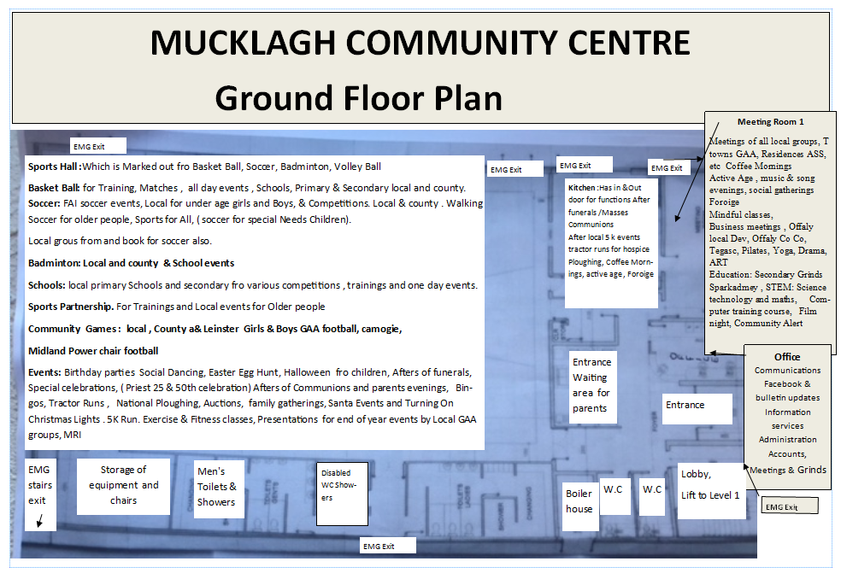

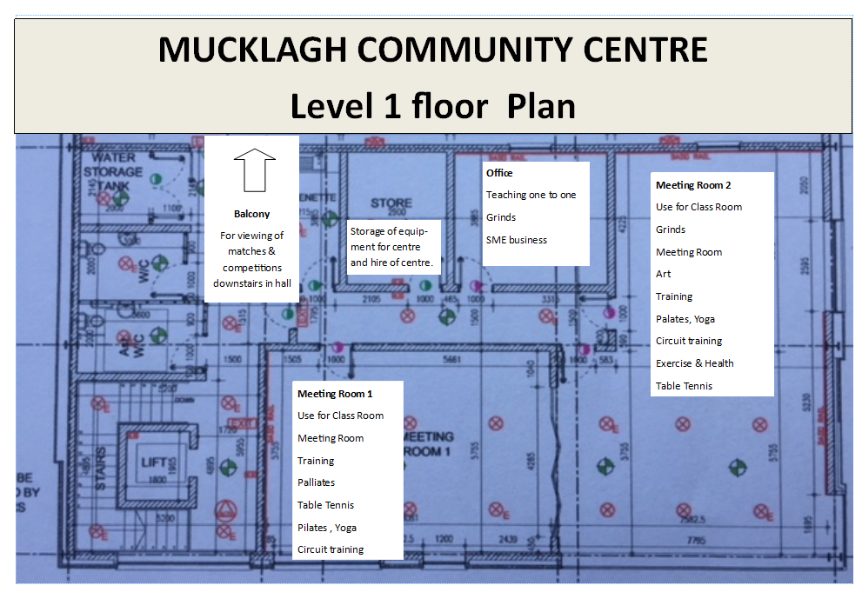

12.0 Risk Assessment Matrix

12.1 Hazard Identification and Risk Assessment Criteria

- Hazards will be identified, risk assessments made and categorised as per our risk assessment formula.
- The policy of the Management of Mucklagh Community Development Ltd. is to identify hazards in the place of work and to assess the risk to Safety and Health and to control risks as far as is practicable so that they are reduced to an acceptable level.
- Hazard is taken to mean “any substance, article, material or practice, which has the potential to cause harm to the Safety, Health or Welfare of employees at work.”
- Risk is taken to mean “the potential for the hazard to cause harm in the actual circumstances of use.”
- Risk Assessment is based on the linking of the probability of occurrence with the severity of loss and/or injury. In this exercise, risks are graded [HIGH] [MEDIUM] or [LOW] and numerically rated using the formula below. This is to help with the giving of priority to the employment of controls and the allocation of resources.

12.2 Risk Assessment Classification

(a) Consider the Likelihood and Severity

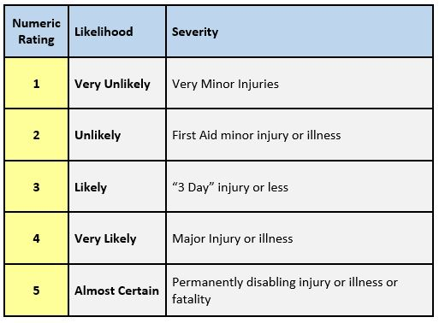

12.0 Risk Assessment Matrix - CONTINUED

(b) Risk Assessment Table (Likelihood x Severity)

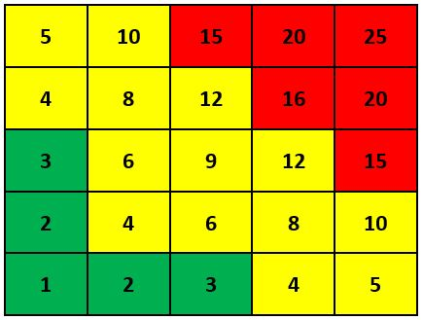
SEVERITY
LIKELIHOOD

(c) Interpretation of Risk Rating

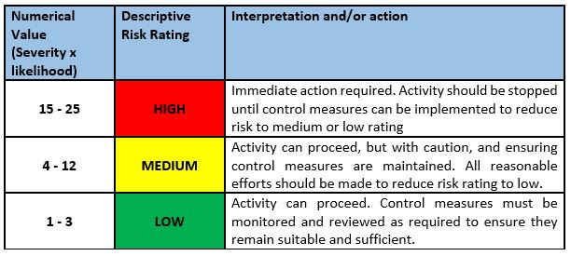

13.0 General Hazards

RA/01 Electricity
RA/02 Fire
RA/03 Slips, Trips and Falls
RA/04 Manual Handling
RA/05 Chemicals
RA/06 Working at Height
RA/07 Display Screen Equipment
RA/08 Office Equipment
RA/09 Broken Glass/ Crockery
RA/10 Cleaning
RA/11 Kitchen Equipment
RA/12 General Equipment
RA/13 Loading/Unloading
RA/14 Manually Operated Hand Tools
RA/15 Noise
RA/16 Vermin and Pest Control
RA/17 Biological Agents
RA/18 Contractors
RA/19 Hiring the hall for parties
RA/20 Hiring the hall for various activities
RA/21 Vehicle movement
RA/22 Hiring of the kitchen
RA/23 Hiring of training rooms
RA/24 Hiring of offices
RA/25 Welfare Facilities

RA/01 Electricity
<>
Activity/Hazard | Use of Electrical Equipment.  Electricity may be used in all areas of work: kitchen appliances, office equipment, power tools.
Risk | Contact with electrical installations or electrical equipment can cause burns, electrocution and other serious injuries.
Risk Rating WITHOUT Controls in Place |  | HIGH
Who Might be Harmed |  | Employees, Visitors.
Consequences | Very serious injuries/burns/death.
<>
Controls/Safe Systems of Work

- All new electrical installations and all extensions are tested and certified as safe, by a competent qualified electrician.
- Electrical installations are checked regularly by a competent qualified electrician.
- Testing, certifying and repairs are carried out in accordance with appropriate E.T.C.I. standards.
- Enclosures/covers are in place to prevent contact with live electrical equipment/parts.
- Damaged extension leads are repaired or removed from use.
- Means of cutting off power to electrical installations and equipment are provided and employees are aware of their locations.
- Work on live electrical equipment is avoided where reasonably practicable.
- Fire extinguishers that are suitable for fighting electrical fires are provided.
- All circuits supplying socket outlets are protected by an RCD.
- Operation of the RCD is tested regularly in accordance with the manufacturer’s instructions.
- Electrical equipment and fittings are suitable for the work environment.
- Where electrical portable appliances are subject to on-going wear and tear, they are inspected and tested.
- Any scorch marks associated with an electrical appliance or electrical wiring is checked urgently by a competent person.
- Electrical cable reels are uncoiled during prolonged use and when using high-power items.
- Report Defects.
- Do not use defective electrical tools.

<>
Persons Responsible | Management, Volunteers, Employees using Electricity
Risk Rating WITH Controls in Place | MEDIUM
<>

RA/02 Fire
<>
Activity/Hazard | Use of Electrical Tools, Smoking, Welding.  Fire could start in any area of the premises. Electrical equipment can go on fire.
Risk | Fire can cause smoke inhalation, burns and other serious injuries.
Risk Rating WITHOUT Controls in Place |  | HIGH
Who Might be Harmed |  | Anyone using electrical tools, smoking on the premises, carrying out welding operations, visitors, members of the community, members of the sponsor group, employees
Consequences | Very serious injuries/burns/death.
<>
Controls/Safe Systems of Work

- Sources of oxygen and ignition are controlled, amounts of flammable materials are minimised and waste is removed daily.
- Fire alarm, manual call points and smoke/heat detectors are in place where necessary, kept in good working order and checked regularly.
- Emergency routes and exits are clearly marked, kept clear at all times and lead directly outside or to a safe area.
- Emergency lights are installed on escape routes where necessary, at and outside exits and near call points/firefighting equipment and are tested regularly.
- Fire extinguishers are accessible, kept in good working order and inspected regularly.
- Employees are trained in how to raise the alarm, what to do in the event of an alarm sounding, emergency evacuation procedures and in the use of fire extinguishers.
- Emergency evacuation procedures are in place.
- Fire drills are held regularly.
- Appropriate signage is in place.

<>
Persons Responsible | Management, Volunteers, All Employees.
Risk Rating WITH Controls in Place | MEDIUM
<>

RA/03 Slips, Trips and Falls
<>
Activity/Hazard | Access and Egress: Walking in and out of the premises, walking to different areas within the premises. Walking around the various area where work is be carried out.
Risk | Slips, Trips and Falls due to spills, inadequate materials storage, bad housekeeping, and tripping hazards on pedestrian routes inadequate lighting can cause injuries.
Risk Rating WITHOUT Controls in Place |  | HIGH
Who Might be Harmed |  | Employees, Visitors.
Consequences | Minor/major Injuries.
<>
Controls/Safe Systems of Work

- Clear, unobstructed, slip-resistant pedestrian routes are provided and maintained.
- Adequate lighting is provided and is appropriate for the work being carried out.
- Absorbent materials and warning signage are available for dealing with spills.
- Spills are cleaned up immediately.
- Mats are properly located, fitted and secured.
- Trailing cables and leads are re-routed, removed or secured.
- Good house-keeping practices are in place and are maintained.
- Changes in levels are avoided if possible or are adequately highlighted where necessary.
- Slip resistant footwear is provided and worn where necessary.
- All pedestrian routes are always kept clear of tripping hazards.
- Remove waste materials.

<>
Persons Responsible | Management,Volunteers, All Employees.
Risk Rating WITH Controls in Place | MEDIUM
<>

RA/04 Manual Handling
<>
Activity/Hazard | Lifting, carrying or moving loads.
Risk | Manual Handling means the lifting, putting down, pushing, pulling, carrying or moving of a load which involves risk of injury due to risk factors such as: Load is too heavy, large, awkward or is carried away from the body. Load is lifted too high or carried too far / too often or involves bending and / or twisting. Inadequate space, uneven floor or steps / ramps.
Risk Rating WITHOUT Controls in Place |  | HIGH
Who Might be Harmed |  | Employees carrying, moving equipment and other materials.
Consequences | Serious injuries to back, limbs and other parts of the body.
<>
Controls/Safe Systems of Work

- Each manual handling task is assessed and measures put in place where needed to avoid or reduce the risks.
- Task is organised to allow the use of mechanical aids to avoid or reduce the need for manual handling.
- Task is organised so that handling is carried out between waist and shoulder height.
- Heavy or large or unwieldy loads are broken down into more manageable weights or sizes or suitable mechanical aids / team lifts are used.
- Work is planned to prevent handling over long distances or frequent repetitions.
- Bending, twisting and unstable postures are avoided.
- Employees receive relevant manual handling training where necessary.

<>
Persons Responsible | Management, Volunteers,All Employees.
Risk Rating WITH Controls in Place | MEDIUM
<>

RA/05 Chemicals
<>
Activity/Hazard | Use of Petrol, Diesel, Oil, Weed killer.  Employees will be exposed to weed killer, petrol, oil when working with strimmers/hedge trimmers, knapsack sprayer. Diesel when operation tractor and mower.
Risk | Exposure to chemicals can cause fires, explosions, skin and eye irritation, cancer, ill health and other serious injuries.
Risk Rating WITHOUT Controls in Place |  | HIGH
Who Might be Harmed |  | Employees using chemicals.
Consequences | Serious ill- health, dermatitis.
<>
Controls/Safe Systems of Work

- A list (inventory) of all chemicals used in the workplace has been prepared.
- Chemical labels and Safety Data Sheets are available for each chemical and the associated hazards of each chemical has been identified.
- Employees are trained in the safe use of chemicals.
- The number of employees and the exposure to chemicals is assessed and minimised.
- Less hazardous chemicals are used where possible.
- Adequate ventilation is provided.
- A wash hand basin, soap and disposable towels/hand dryer are available.
- All chemicals are used, stored and disposed of in accordance with the Safety Data Sheet or supplier recommendations.
- Eye, skin and respiratory protection is provided and worn where appropriate and in accordance with the Safety Data Sheet.

<>
Persons Responsible | Management, Volunteers, All Employees.
Risk Rating WITH Controls in Place | MEDIUM
<>

RA/06 Work at Height
<>
Activity/Hazard | Working at Height.  There will be working at height when carrying out painting or hanging baskets in position. There may be some cleaning operations at a height e.g. cleaning out gutters. Putting up decorations
Risk | Work at height and falling objects can cause fractures, head injuries, death and other serious injuries.
Risk Rating WITHOUT Controls in Place |  | HIGH
Who Might be Harmed |  | Employees carrying out activities at a height.
Consequences | Serious injuries.
<>
Controls/Safe Systems of Work

- Work at height is avoided where possible.
- Appropriate work equipment e.g. scaffolding, mobile working platforms, scissors lifts, are used to prevent falls where work at height cannot be avoided.
- Where falls cannot be prevented, work equipment e.g. safety nets, bean bags, airbags are used.
- Equipment that protects all employees who work at height is used instead of equipment that only protects one employee at a time e.g. safety nets instead of safety harnesses.
- Work at height activities are planned and supervised.
- Training is provided for employees who work at height.
- Safe access to work at height area is provided.
- Work equipment is inspected regularly and any defects found are repaired.
- Work areas at height are stable, strong and have a 1m high parapet or double handrails.
- Ladders will be used where risk is low and work of short duration.
- Step-ladders may be used.
- Personal Protective Equipment (e.g. safety harness) is provided and employees are trained in its use.
- Materials stored at height are secured.
- Work areas at height are kept clear of loose materials and material fall prevention systems are in place.
- Hall users to know (through hire agreement) that they are responsible for using the stepladder safely.

<>
Persons Responsible | Management, Volunteers, All Employees.
Risk Rating WITH Controls in Place | MEDIUM
<>

RA/07 Display Screen Equipment
<>
Activity/Hazard | Use of VDU/DSE.  Employee employed in the office area at the Mucklagh Community Development will be using computers and other office equipment
Risk | Poor workstation set up, prolonged Display Screen Equipment (DSE) use and prolonged poor seating posture at DSE workstation can cause neck, back, shoulder or arm strain, eye strain or fatigue.
Risk Rating WITHOUT Controls in Place |  | HIGH
Who Might be Harmed |  | Employees using computers.
Consequences | Musculoskeletal injuries, eye fatigue, stress.
<>
Controls/Safe Systems of Work

- An assessment of individual workstations is carried out.
- Work tasks are varied to ensure that staff are not working at their computers for long periods of time.
- Employees are given information and training on the hazards associated with computer use and the steps they can take to minimise the effect of these hazards.
- Employees who use computers are made aware of their right to eye tests.

<>
Persons Responsible | Management, Volunteers, All Employees.
Risk Rating WITH Controls in Place | MEDIUM
<>

RA/08 Office Equipment
<>
Activity/Hazard | Use of Office Equipment.
Risk | Working with office equipment/furniture (e.g. photocopiers, shredders, guillotines, filing cabinets) may cause cuts, burns and other serious injuries.
Risk Rating WITHOUT Controls in Place |  | HIGH
Who Might be Harmed |  | Employees.
Consequences | Serious injuries or ill-health.
<>
Controls/Safe Systems of Work

- Office equipment is used in accordance with the manufacturer’s manual.
- Power sockets are not overloaded.
- Power supply is turned off when clearing shredder jams and emptying bags.
- Loose clothing, dangling jewellery and unsecured long hair should be avoided when using shredders.
- Guillotine is only used when the guard is in place.
- Guard is engaged when guillotine is not in use.
- Cabinet drawers and doors are kept closed when not in use.
- Only one filing cabinet drawer can be opened at a time to prevent tipping.
- Shelves are not overloaded.
- Adequate lighting, ventilation and heating are provided.

<>
Persons Responsible | Management, Volunteers, All Employees.
Risk Rating WITH Controls in Place | MEDIUM
<>

RA/09 Broken Glass/Crockery
<>
Activity/Hazard | Contact with broken glass crockery.
Risk | Contact with broken glass and crockery can cause cuts, lacerations and other serious injuries.
Risk Rating WITHOUT Controls in Place |  | HIGH
Who Might be Harmed |  | Employees, Visitors.
Consequences | Serious injuries or ill-health.
<>
Controls/Safe Systems of Work

- A bin is designated and labelled for broken glass and crockery.
- Broken glass and crockery are immediately placed in bin.
- Protective gloves are provided and worn.

<>
Persons Responsible | Management, Volunteers, All Employees.
Risk Rating WITH Controls in Place | MEDIUM
<>

RA/10 Cleaning
<>
Activity/Hazard | Performing/being exposed to cleaning activities.
Risk | Cleaning activities can result in awkward postures, use of cleaning chemicals and equipment, and slips, trips and falls which may cause back injury, skin conditions, cuts and other serious injuries or ill health.
Risk Rating WITHOUT Controls in Place |  | HIGH
Who Might be Harmed |  | Employees carrying out cleaning operations.
Consequences | Serious injuries or ill-health.
<>
Controls/Safe Systems of Work

- Employees are given information on the cleaning activities to be carried out and are trained in safe cleaning and good hygiene procedures.
- Trolleys are provided and used where needed.
- Furniture is suitably arranged or fitted with casters/glides for ease of movement where possible.
- Suitable gloves are provided and worn.
- Equipment used for cleaning is visually inspected before use, reported defects are dealt with promptly and unsafe equipment is taken out of use.
- Safe practices are in place for the use of cleaning equipment and employees are instructed to adjust equipment as required.
- Employees are made aware of the chemicals they are using and safe use.
- Correct manual handling techniques to be used when sweeping and mopping.

<>
Persons Responsible | Management, Volunteers, All Employees.
Risk Rating WITH Controls in Place | MEDIUM
<>

RA/11 Kitchen Equipment
<>
Activity/Hazard | Using kitchen equipment. |  | 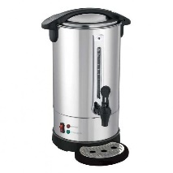
Risk | The use of a coffee machine/cafe boiler may result in steam explosions which may cause burns, scalds and other serious injuries.
Risk Rating WITHOUT Controls in Place |  | HIGH
Who Might be Harmed |  | Employees, Visitors.
Consequences | Serious injuries or ill-health.
<>
Controls/Safe Systems of Work

- Machine is installed, used and maintained by a competent person in accordance with the manufacturer's instructions and manufacturer's manual is available.
- Suitable protective devices are fitted to steam generating machines and adjusted by a competent person and kept in good condition.
- Employees are trained in the use of the machine and operator's manual is available.
- Power to the machine is switched off before any maintenance work is carried out.
- Equipment is kept in good working order, reported defects are dealt with promptly and unsafe equipment is taken out of use.

<>
Persons Responsible | Management, Volunteers, All Employees.
Risk Rating WITH Controls in Place | MEDIUM
<>

RA/12 General Equipment
<>
Activity/Hazard | Using general equipment.
Risk | Use of defective equipment or wrong use of equipment may cause cuts, bruises, electric shock, back, crush or other serious injuries.
Risk Rating WITHOUT Controls in Place |  | HIGH
Who Might be Harmed |  | Employees.
Consequences | Serious injuries or ill-health.
<>
Controls/Safe Systems of Work

- Equipment is used and maintained in accordance with the manufacturer's instructions.
- Equipment is maintained in good condition, reported defects are dealt with promptly and unsafe equipment is taken out of use.
- Employees are trained in the safe operation of equipment.

<>
Persons Responsible | Management, Volunteers, All Employees.
Risk Rating WITH Controls in Place | MEDIUM
<>

RA/13 Loading/Unloading
<>
Activity/Hazard | Loading/unloading vehicles.
Risk | Loading or unloading vehicles can cause crush, head and other serious injuries.
Risk Rating WITHOUT Controls in Place |  | HIGH
Who Might be Harmed |  | Employees.
Consequences | Serious injuries or ill-health.
<>
Controls/Safe Systems of Work

- A designated, clearly marked, flat area is used for loading and unloading vehicles and access is restricted.
- Vehicles are braked, chocked and/or stabilised to prevent movement during loading/unloading.
- Loads are spread evenly, vehicles are not overloaded and all loads are secured.
- Lifting equipment used for loading/unloading is certified and the operator of lifting equipment is trained.
- Where it is necessary to access the vehicle or load, a safe means of getting on and off is provided and measures are in place to prevent falls.
- Pallets and cages are checked for defects and if damaged are taken out of use.
- Loading bays are designed and located to ensure safe access.
- A designated safe area is provided for drivers during loading/unloading.
- Roadside loading or unloading is carried out in a safe manner ensuring suitable precautions are taken with regard to pedestrians and road traffic movements.

<>
Persons Responsible | Management, Volunteers, All Employees.
Risk Rating WITH Controls in Place | MEDIUM
<>

RA/14 Manually Operated Hand Tools
<>
Activity/Hazard | Manually operating hand tools.
Risk | Contact with manually operated hand tools can cause cuts, lacerations and other serious injuries.
Risk Rating WITHOUT Controls in Place |  | HIGH
Who Might be Harmed |  | Employees.
Consequences | Serious injuries or ill-health.
<>
Controls/Safe Systems of Work

- Hand tools are checked before use, reported defects are dealt with promptly and unsafe equipment is taken out of use.
- Employees are informed of the possible risks when using the hand tools.
- Adequate lighting is available.
- Bench vice is provided and used in workshops as required.
- PPE is provided and worn as required.

<>
Persons Responsible | Management, Volunteers, All Employees.
Risk Rating WITH Controls in Place | MEDIUM
<>

RA/15 Noise
<>
Activity/Hazard | Exposure to noise.
Risk | Exposure to noise can cause hearing damage and cause stress.
Risk Rating WITHOUT Controls in Place |  | HIGH
Who Might be Harmed |  | Employees, Visitors.
Consequences | Serious injuries or ill-health.
<>
Controls/Safe Systems of Work

- Noisy areas/activities have been identified, and ways to reduce levels and exposure have been considered.
- Warning signs are displayed in the workplace.
- Employees are advised of the risks from exposure to noise.
- Hearing protection is provided and worn where necessary, especially when working with or working close to noisy equipment.

<>
Persons Responsible | Management, Volunteers All Employees.
Risk Rating WITH Controls in Place | MEDIUM
<>

RA/16 Vermin and Pest Control
<>
Activity/Hazard | Contact with vermin.
Risk | Contact with vermin or their bodily fluids may result in bites or infection which could cause serious ill health.
Risk Rating WITHOUT Controls in Place |  | HIGH
Who Might be Harmed |  | Employees, Visitors.
Consequences | Serious injuries or ill-health.
<>
Controls/Safe Systems of Work

- Vermin eradication programme is in place where practical.
- Good housekeeping and storage arrangements are in place.
- Good hygiene practices are in place.
- Contact with stagnant water or water that may be contaminated is avoided.
- PPE is provided and worn as required.

<>
Persons Responsible | Management, Volunteers, All Employees.
Risk Rating WITH Controls in Place | MEDIUM
<>

RA/17 Biological Agents
<>
Activity/Hazard | Contact with biological agents while working close to water, weed-killing, landscaping, sowing plants.
Risk | Weil’s Disease, ill-health.
Risk Rating WITHOUT Controls in Place | HIGH
Who Might be Harmed | You, your employees and/or visitors.
Consequences | Serious injuries or ill-health.
<>
Controls/Safe Systems of Work

- Ensure PPE is worn to avoid skin contact with clay and contaminated earth.
- Good hygiene practices to be employed to ensure contaminants are not ingested.

<>
Persons Responsible | Management, Volunteers, All Employees.
Risk Rating WITH Controls in Place | MEDIUM
<>

RA/18 Contractors
<>
Activity/Hazard | Construction- Repair/Maintenance Works
Risk | Slips, trips and falls, collisions with moving vehicles, inhalation of harmful substances.
Risk Rating WITHOUT Controls in Place |  | HIGH
Who Might be Harmed |  | Visitors to the Mucklagh Community Development, Employees, other contractors
Consequences | Ill-Health, Severe/Minor injuries
<>
Controls/Safe Systems of Work:

- Emergency Plans in place.
- Contractor provides evidence of competency.
- Wear the correct PPE.
- Comply with site rules and induction training.
- Provide evidence of safety statement & risk assessments signed.
- Complete SSWP and sign.
- Provide evidence of Insurance.

<>
Persons Responsible | Management, Volunteers, All Employees
Risk Rating WITH Controls in Place | MEDIUM
<>

RA/19 Hiring the hall for parties for children under 12 years old
<>
Activity/Hazard | Hiring the hall for parties for children under 12 years old
Risk | Slips, trips , falls, falls from a height, children go missing if not adequately supervised, burns from appliances in the kitchen
Risk Rating WITHOUT Controls in Place |  | HIGH
Who Might be Harmed |  | Members of the Public, Employees and visitors
Consequences | Severe/Minor Injuries
<>
Controls/Safe Systems of Work:

- There should be at least 4 supervising adults in the Community Centre for the duration of the party.
- NO food or drink is permitted in the Hall at any time during the party.
- NO children are allowed into the kitchen
- ALL children must be supervised and under no circumstances are children allowed to leave the community centre unless with a supervising adult.
- Attendees are only allowed access rooms attached to the hire.
- Uses of Bouncy Castles are not permitted.
- Hirers can bring their own equipment into the hall, but must make sure it is safe and complies with all relevant laws.
- Griping or hanging out of baskets is forbidden
- No hitting basketball or soccer ball off Heating system and Score Board
- Strictly no climbing wall to go to balcony
- There is a yellow line along the walls of the hall, the soccer ball must not go higher than this line.
- Footwear with anti-slip soles must be worn. High heels may not be worn
- Children are not allowed up on balcony unless accommodated by an adult.
- No Smoking in in centre.
- Users of the hall must clear up spillages immediately and be informed where equipment for this is kept before the party begins
- There must be no trailing electrical leads/cables.
- Mats should be provided at entrances to stop rain water being carried in
- No storage in corridors this includes coats and bags belonged to children/ hall users
- Portable equipment checked for visual signs of damage before use
- Hall users should be made aware of where the fuse box is and how to switch supply off in an emergency.

Controls Continued
- Users must be aware that they must stack tables and chairs carefully so that they do not collapse
- If entertainers are acquired by the hall user they must provide risk assessments specific to the games/ shows they shall carry out.
- No small prizes /objects to be given to children under 3 as this is a choking hazard
- Dispose of all burst balloons as this is also a choking hazard for young children
- Make sure all children / supervisors have adequate personal space to avoid bumps and knocks from overcrowding
- The Hirer must know where all safe exits and exit paths are located and designate a safe external assembly point
- Keep all exits and exit paths clear during use of the Community Hall and know where emergency equipment is located (eg. fire extinguishers)
- Ensure activities to be undertaken by the Hirer and the Hirer’s guests are not dangerous
- It is strictly forbidden to interfere with any emergency equipment or notices
- The Hirer must ensure they have their own first aid kit with them when entering the hall

Persons Responsible | Management, Volunteers, All Employees
Risk Rating WITH Controls in Place | MEDIUM

RA/20 Hiring of hall for various activities
<>
Activity/Hazard | Hiring of hall for various activities |  | 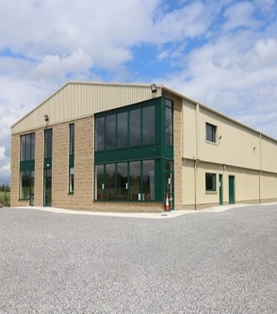
Risk | Slips , trips , falls, falls from a height, collisions with other people in the hall , fire
Risk Rating WITHOUT Controls in Place |  | HIGH
Who Might be Harmed |  | Employees, Employers, members of the public and visitors
Consequences | Severe/Minor Injuries

Controls/Safe Systems of Work:
- NO food or drink is permitted in the Hall at any time
- NO alcohol may sold or consumed on the premises
- NO children are allowed into the kitchen
- ALL children present must be supervised
- Attendees are only allowed access rooms attached to the hire.
- Uses of Bouncy Castles are not permitted.
- Hirers can bring their own equipment into the hall, but must make sure it is safe and complies with all relevant laws.
- Griping or hanging out of baskets is forbidden
- No hitting basketball or soccer ball off Heating system and Score Board
- Strictly no climbing wall to go to balcony
- There is a yellow line along the walls of the hall, the soccer ball must not go higher than this line.
- Footwear with anti-slip soles must be worn. High heels may not be worn
- Children are not allowed up on balcony unless accommodated by an adult.
- No Smoking in in centre.
- Users of the hall must clear up spillages immediately and be informed where equipment for this is kept before the party begins
- There must be no trailing electrical leads/cables.
- Mats should be provided at entrances to stop rain water being carried in
- No storage in corridors this includes coats and bags belonged to children/ hall users
- Portable equipment checked for visual signs of damage before use
- Hall users must know where the fuse box is and how to switch supply off in an emergency.
- Users must be aware that they must stack tables and chairs carefully so that they do not collapse
- If entertainers are acquired by the hall user they must provide risk assessments specific to the games/ shows they shall carry out.

Controls Continued
- The Hirer must know where all safe exits and exit paths are located and designate a safe external assembly point
- Keep all exits and exit paths clear during use of the Community Hall and know where emergency equipment is located (eg. fire extinguishers)
- Ensure activities to be undertaken by the Hirer and the Hirer’s guests are not dangerous
- It is strictly forbidden to interfere with any emergency equipment or notices
- The Hirer must ensure they have their own first aid kit with them when entering the hall

Persons Responsible | Management, Volunteers, All Employees
Risk Rating WITH Controls in Place | MEDIUM
<>

RA/21 Vehicle Movement
<>
Activity/Hazard | Vehicle Movement |  | 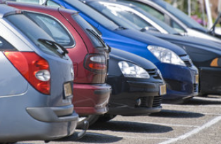
Risk | Collisions with pedestrians and other vehicles
Risk Rating WITHOUT Controls in Place |  | HIGH
Who Might be Harmed |  | Drivers of Vehicles, Members of the Public
Consequences | Severe/Minor Injuries
<>
Controls/Safe Systems of Work:

- Entrance/exit to car park clearly marked.
- For large events, parking controlled by marshals wearing high-visibility vests.
- Car park well lit.
- Skip/recycling collection takes place at times when hall not in use.
- Car park surface maintained to be as even as possible.
- Parking spaces for visitors with disabilities available next to hall entrance.
- Advise users of hall, through hire agreement, to consider whether they need to control car parking.
- Apply 5 mph speed limit in car park and put up signs.
- Surface to be inspected regularly and repaired as necessary.

<>
Persons Responsible | Management, Volunteers, All Employees
Risk Rating WITH Controls in Place | MEDIUM
<>

RA/22 Hiring of the kitchen
<>
Activity/Hazard | Hiring of the kitchen
Risk | Slips , trips , falls, cuts , burns , electrocution, fire
Risk Rating WITHOUT Controls in Place |  | HIGH
Who Might be Harmed |  | Employees, Employers, members of the public and visitors
Consequences | Severe/Minor Injuries
<>
Controls/Safe Systems of Work:
- Manuals are available in the kitchen for the following appliances:
a. Water Heater
b. Hob/Ovens;
c. Microwave
d. Fridge/Freezer.
- All work surfaces to be left spotless when leaving the kitchen
- Any pans or containers that have been used to be washed and put away in the correct drawers.
- The Hirer should note all fire exits, fire extinguishers and emergency procedures provided within the facility. The Hirer should be aware of emergency procedures as displayed within the facility.
- The Hirer is responsible to the leave the premises in a clean and tidy condition. All rubbish, refuse and waste must be disposed of in appropriate manner in accordance with the local waste disposal authority.
- The Hirer must ensure that all lights and electrical appliances, including heating and cooling are switched off before vacating the facility and are not used unnecessarily.
- The Hirer must ensure that all windows, doors and points of entry are properly locked / secured when vacating the facility
- The hirer must provide their own first aid box when using the kitchen
- Children are strictly forbidden from entering the kitchen
- No smoking permitted in the kitchen or in any part of the building

<>
Persons Responsible | Management, Volunteers, All Employees
Risk Rating WITH Controls in Place | MEDIUM

RA/23 Hiring of training rooms
<>
Activity/Hazard | Hiring of training rooms
Risk | Slips , trips , falls, in the event of a fire- evacuation routes may not be known to people being trained
Risk Rating WITHOUT Controls in Place |  | HIGH
Who Might be Harmed |  | Employees, Employers, members of the public and visitors
Consequences | Severe/Minor Injuries

Controls/Safe Systems of Work:
- The room must be large enough to comfortably facilitate the number of people for which the training is intended
- The room must be well ventilated and well lit
- The room must be of an adequate size that allows flexibility of layout for the types of training to be carried out safely and with a minimum of risk (both in terms of the trainer and the trainees) and adheres to any guidelines or stipulations issued by training provider/developer
- There should be non-Slip flooring
- The room must only contains furniture and equipment required for intended training (i.e. tables, chairs etc.)
- There must be access to canteen facilities (tea, coffee, water, place to eat lunch)
- Signage may be provided directing participants to the room if necessary
- There must be access to toilets within the building for the trainer and persons being trained
- Outside noise levels should not be excessive in a way which might affect delivery of training
- There must be suitable number of power points to allow set up of equipment and to avoid trailing leads across the floor
- The Hirer should note all fire exits, fire extinguishers and emergency procedures provided within the facility. The Hirer should be aware of emergency procedures as displayed within the facility.
- No smoking permitted in the training room or in any part of the building
- The Hirer must ensure that all lights and electrical appliances are switched off before vacating the facility.
Persons Responsible | Management, Volunteers, All Employees
Risk Rating WITH Controls in Place | MEDIUM
<>

RA/23 Hiring of offices
<>
Activity/Hazard | Hiring of offices
Risk | Slips , trips , falls, headaches, back strain
Risk Rating WITHOUT Controls in Place |  | HIGH
Who Might be Harmed |  | Employees, Employers, members of the public and visitors
Consequences | Severe/Minor Injuries

Controls/Safe Systems of Work:
- The room must be large enough to comfortably facilitate the number of people for which the office is intended
- The minimum temperature allowed in an office space is 17.5 Degrees Celsius
- Windows, skylights and glass partitions should not allow excessive temperatures to be reached during hot weather
- Work stations should be comfortable and ergonomic, with suitable chairs and sufficient space
- There must be at least 4.65 square meters of floor space for each person while working in the office
- If artificial lighting is used, it should be sufficient so as to avoid visual fatigue and reflection into workers eyes.
- There must be suitable number of power points to allow set up of equipment and to avoid trailing leads across the floor
- The Hirer should note all fire exits, fire extinguishers and emergency procedures provided within the facility. The Hirer should be aware of emergency procedures as displayed within the facility.
- No smoking permitted in the office or in any part of the building
- The Hirer must ensure that all lights and electrical appliances are switched off before vacating the facility.
Persons Responsible | Management, Volunteers, All Employees
Risk Rating WITH Controls in Place | MEDIUM
<>

RA/25 Welfare Facilities
<>
Activity/Hazard | Welfare Facilities
Risk | Infection from unclean facilities, cuts from broken tiles , slips from wet floors
Risk Rating WITHOUT Controls in Place |  | HIGH
Who Might be Harmed |  | Employees, Employers, members of the public and visitors
Consequences | Severe/Minor Injuries

Controls/Safe Systems of Work:
- All welfare facilities such as canteens, showers, toilets and sinks shall be maintained and cleaned regularly by a competent person
- Non slip flooring shall be provided around the shower area to prevent slips on the wet surface
- If the welfare facilities require attention this must be notified immediately to the relevant person
- Any leaks or broken tiles to be reported as soon as possible to a member of staff for remedial action to be taken without delay
- Welfare facilities will be available to all personnel using the hall including the offices and training rooms

Persons Responsible | Management,Volunteers, All Employees
Risk Rating WITH Controls in Place | MEDIUM
<>

RA/26 Use of Lift
<>
Activity/Hazard | Lift
Risk | Collapse, Crush injury from moving doors, Falls into lift shaft, Persons trapped in lift, Trip hazards from car and landing at different levels, contact lift drive system.
Risk Rating WITHOUT Controls in Place |  | HIGH
Who Might be Harmed |  | Employees, Employers, members of the public and visitors, school children & teachers
Consequences | Severe/Minor Injuries/ Stress

Controls/Safe Systems of Work:
The HSA would advise all employers in all sectors that passenger and goods lifts including pavement hoists and dumb waiters, are subject to requirements set out in chapter 2 of the Safety, Health and Welfare at Work (General Application) Regulations, [S.I No.299 and 732 of 2007].
Lifts must have a periodic thorough examination by a competent person every 6 months. Reports of such examinations shall be kept available for inspection by a HSA inspector.
All repairs required to lifts must also be carried out by a competent person.
Teachers and children are required to use the stairs available.
Lift only to be used if necessary and under strict supervision of an adult.
Clear instructions on use to be displayed inside the car.
Do not use the lift in the case of an emergency evacuation. Use the stairs and nearest exit on ground floor.

Persons Responsible | Management, Volunteers,Teachers All Employees
Risk Rating WITH Controls in Place | MEDIUM
<>

RA/26 Use of rooms as classrooms for NS school children
<>
Activity/Hazard | National School Activities
Risk | Slips, trips, & falls, Fire
Risk Rating WITHOUT Controls in Place |  | HIGH
Who Might be Harmed |  | School Children & Teachers, Inspectors
Consequences | Serious injuries/death/minor injuries

Controls/Safe Systems of Work:
Safe access & egress to be provided.
Stairs to be kept in good order and free from tripping hazards.
Emergency Procedures to be in place with all teachers informed to what to do in the case of an emergency situation e.g. fire and emergency evacuation.
National School to provide a copy of their Safety Statement & Risk Assessments relevant to
Activities of children and teachers using the upstairs rooms.
Lift not to be used except in cases where the stairs cannot be used e.g. disability.
Lift only to be used by children under strict supervision of an adult.

Persons Responsible | Management, Volunteers, Teachers  All Employees
Risk Rating WITH Controls in Place | MEDIUM
<>

13.0 Site Specific Operations and Controls

Area 1: Training Rooms
Area 2: Office
Area 3: Kitchen
Area 4: Main Hall
Area 5: Welfare Facilities
Area 6: Storage Areas
Area 7: Reception
Area 8: Parking Area
Area 9: Second Floor

Training Rooms | Mucklagh Community Development Ltd.
Activities | Equipment and Machinery Used |  | Risk Assessments
- Training | Desks  Chairs  Computer  Projector  Cleaning equipment |  | RA/01  RA/02  RA/03  RA/04  RA/05  RA/07  RA/08  RA/10  RA/11  RA/12  RA/23  RA/25
Number of Employees/Volunteers in this Area:

Area 2  Office | Mucklagh Community Development Ltd.
Activities | Equipment and Machinery Used |  | Risk Assessments
- Use of computers  - Office administration | Computers  Chairs  Desks  Phones  Pens  Paper |  | RA/01  RA/02  RA/03  RA/07  RA/08  RA/10  RA/24  RA/25
Number of Employees/Volunteers in this Area:

Area 3  Kitchen | Mucklagh Community Development Ltd.
Activities | Equipment and Machinery Used |  | Risk Assessments
Kitchen | Water Boiler  Oven  Microwave |  | RA/01  RA/02  RA/03  RA/04  RA/05  RA/06  RA/09  RA/10  RA/11  RA/12  RA/13  RA/16  RA/22  RA/25
Number of Employees/Volunteers in this Area:

Area 4  Main Hall | Mucklagh Community Development Ltd.
Activities | Equipment and Machinery Used |  | Risk Assessments
Main Hall | Tables  Chairs  Footballs  Badminton Rackets and Nets |  | RA/01  RA/02  RA/03  RA/04  RA/05  RA/06  RA/10  RA/12  RA/14  RA/15  RA/16  RA/25
Number of Employees/Volunteers in this Area:

Area 5  Welfare Facilities | Mucklagh Community Development Ltd. |  | 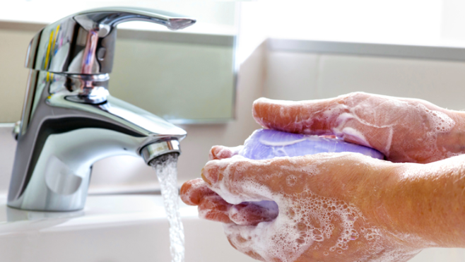
Activities | Equipment and Machinery Used |  | Risk Assessments
Washing hands  Showers  Canteen | Tables  Chairs  Sinks and showers  Cleaning equipment |  | RA/03  RA/04  RA/05  RA/06  RA/10  RA/12  RA/14  RA/15  RA/16  RA/25
Number of Employees/Volunteers in this Area:

Area 6  Storage Areas | Mucklagh Community Development Ltd. |  | 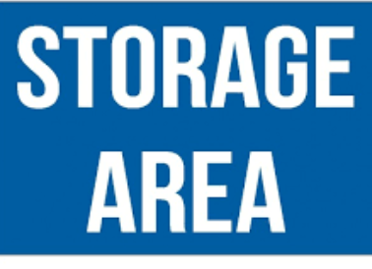
Activities | Equipment and Machinery Used |  | Risk Assessments
Storage of chairs, tables, equipment for the hall and cleaning utensils | Chairs  Tables  Mop and Bucket  Cleaning equipment |  | RA/01  RA/02  RA/03  RA/04  RA/05  RA/06
Number of Employees/Volunteers in this Area:

Area 7  Reception | Mucklagh Community Development Ltd. |  | 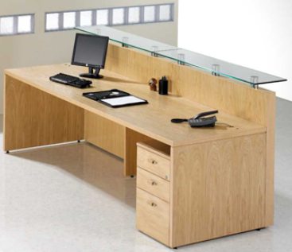
Activities | Equipment and Machinery Used |  | Risk Assessments
Use of computer  Maintaining area | Desk  Shelves  Chair  Computer  Cleaning utensils |  | RA/01  RA/02  RA/03  RA/04  RA/05  RA/07  RA/08  RA/10  RA/12  RA/25
Number of Employees/Volunteers in this Area:

Area 8  Parking Area | Mucklagh Community Development Ltd.
Activities | Equipment and Machinery Used |  | Risk Assessments
Parking of Cars  Unloading of equipment from vehicles  Upkeep of car park | Vehicles  Cones |  | RA/03  RA/04  RA/05  RA/12  RA/21
Number of Employees/Volunteers in this Area:

Area 9  Use of Second Floor  Classrooms and storage area. | Mucklagh Community Development Ltd.
Activities | Equipment and Machinery Used |  | Risk Assessments
Classroom Activities | Desk  Shelves  Chair  Computer  Cleaning |  | RA/01  RA/02  RA/03  RA/04  RA/05  RA/07  RA/08  RA/10  RA/12  RA/25  RA/26
Number of Employees/Volunteers in this Area:

Appendix 1: General Principles of Prevention

The General Principles of Prevention are set out in descending order of preference as follows:

- Avoid risks.
- Evaluate unavoidable risks.
- Combat risks at source.
- Adapt work to the individual, especially the design of places of work
- Adapt the place of work to technical progress.
- Replace dangerous articles, substances, or systems of work by non-dangerous or less dangerous articles, substances, or systems
- Use collective protective measures over individual measures
- Develop an adequate prevention policy
- Give appropriate training and instruction to employees.

Signature Page

I am aware of the contents of this Safety Statement and agree to comply with
all control measures and rule of the centre contained therein.
Name (PRINT) | Signature | Volunteer  Committee Member  Person in charge of groups | Activities taking place in the centre | Date

Signature Page

I am aware of the contents of this Safety Statement and agree to comply with
all control measures and rule of the centre contained therein.
Name (PRINT) | Signature | Volunteer  Committee Member  Person in charge of groups | Activities taking place in the centre | Date

Signature Page

I am aware of the contents of this Safety Statement and agree to comply with
all control measures and rule of the centre contained therein.
Name (PRINT) | Signature | Volunteer  Committee Member  Person in charge of groups | Activities taking place in the centre | Date

Signature Page

I am aware of the contents of this Safety Statement and agree to comply with
all control measures and rule of the centre contained therein.
Name (PRINT) | Signature | Volunteer  Committee Member  Person in charge of groups | Activities taking place in the centre | Date

Signature Page

I am aware of the contents of this Safety Statement and agree to comply with
all control measures and rule of the centre contained therein.
Name (PRINT) | Signature | Volunteer  Committee Member  Person in charge of groups | Activities taking place in the centre | Date

Signature Page

I am aware of the contents of this Safety Statement and agree to comply with
all control measures and rule of the centre contained therein.
Name (PRINT) | Signature | Volunteer  Committee Member  Person in charge of groups | Activities taking place in the centre | Date

Signature Page

I am aware of the contents of this Safety Statement and agree to comply with
all control measures and rule of the centre contained therein.
Name (PRINT) | Signature | Volunteer  Committee Member  Person in charge of groups | Activities taking place in the centre | Date

